BRIT AVODAH: Covenant of Service
for Board Members of Union for Reform Judaism Congregations
Do what is right and good in the sight of the Eternal. Deuteronomy 6:18
It is the responsibility of Board Members of congregations of the Union for Reform Judaism (URJ) to ensure that the synagogue is an ethical stronghold in all its pursuits and dealings. Board Members should be guided by kedushah (holiness) in promoting the synagogue’s mission of sustaining Judaism. Their role is that of “managing the sacred,” by bringing vision, wisdom and dedication to their duties. Board Members enter into a brit kodesh (sacred covenant). In doing so, they will adhere to the following principles:

Congregational Expectations

Board Members are expected to:
- Set the synagogue’s mission and purpose, goals and strategic direction and implement these through congregational programs and services, working closely with clergy and staff (in those congregations with clergy and staff).
- Be actively involved in the organizational and communal life of the synagogue by frequently attending worship services, Board and committee meetings along with congregational events.
- Be familiar with the congregation’s by-laws, policies and traditions, as well as its financial affairs.
- Ensure sound financial and organizational structure and procedures and exercise fiduciary oversight.
- Be responsive to the congregation’s members, providing support and listening to their needs.
- Strengthen the congregation’s role in the local community, relationship to the URJ and to Israel.

Personal Expectations

Board Members should expect to:
- Gain spiritual and personal growth through prayer and Jewish study.
- Set an example through personal commitment and actions, serving as role models.
- Use their skills to participate fully and thoughtfully in synagogue governance.
- Work collaboratively with the clergy, professional staff (in those congregations with clergy and staff) and members of the congregation.
- Act as advocates and positive spokespersons for the synagogue, its personnel, programs, and policies.
- Embrace tzedakah (righteous action) by financially supporting their synagogue to the best of their ability.
- Be part of the creative process of sustaining Jews and Judaism l’dor v’dor (from generation to generation).
- Board Members can expect to be appropriately recognized for their efforts.

Accountability

Board Members are accountable for:
- Decision-making based upon Jewish values such as fairness, derech eretz, mutual respect, sensitivity, and open- ness.
- Acting with personal honesty and integrity, including avoiding personal gain and completing the Conflict of Interest form.
- Providing oversight and fiscal responsibility so that resources are used effectively.
- Engaging in regular evaluation of policies, programs, procedures and personnel.
- Preserving the dignity of the synagogue, each of its members and those who serve it.
- Supporting both positively and Jewishly the daily work of the clergy and professional staff (in congregations with clergy and professional staff),
- Creating a safe and welcoming environment, built on trust, for all congregants and employees (where there are employees.

Communication and Confidentiality

Board Members are responsible for:
- Ensuring that matters requiring confidentiality are unequivocally respected.
- Upholding to the highest standards the laws of la-shon harah (idle gossip or slanderous talk).
- Respecting the privacy of deliberations and discussions that take place within meetings.
- Communicating openly and truthfully with fellow lay leaders, clergy, professional staff and congregants.
- Ensuring that criticism of policy, positions, programs, or individuals is expressed constructively and addressed to the appropriate party.
- Ensuring that disagreement relates only to principles and priorities, not personalities.

Respect for Others

Board Members are responsible for:
- Ensuring that everyone involved in synagogue life is treated with kavod (respect).
- Enabling those who are connected with synagogue life to reach their highest potential.
- Teaching that all are created b’tzelem Elohim (in the image of God).
- Remembering and reminding others that the goal is unity, not uniformity.
- Ensuring that respect for boundaries, prerogatives and expertise is the norm and that the position/office/calling of the clergy, professional staff and lay leaders is worthy of respect.

It was not with our fathers that Adonai made this covenant, but with us, the living, every one of us who is here today. (Deuteronomy 5: 3)

The privileges and benefits bestowed upon Board members are a blessing, creating the opportunity for personal growth through service to the Jewish community. By living a committed Jewish life, each of us can improve while contributing to tikkun olam (repair of the world).

Name: _____________________________ _ Date: _______________

President: ________________________________ Date: _______________

Rabbi: ________________________________ Date: _______________

Joint Commission on Synagogue Management June 2005

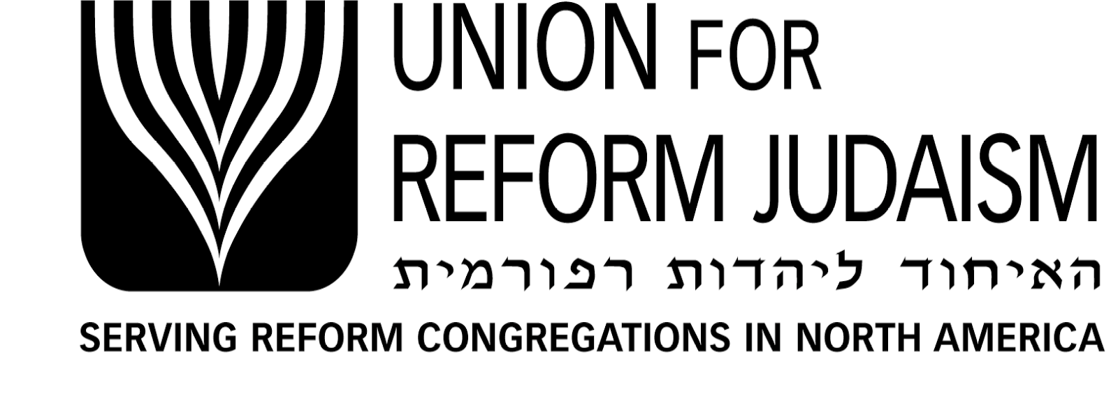
Ida and Howard Wilkoff
Department of Synagogue Management
633 Third Avenue, New York, NY 10017-6778 P: 212.650.4040 F: 212.650.4239
synagoguemgmt@urj.org www.urj.org/synmgmt

